Sairam Soundararajan

CMSC350: Data Structures and Analysis

University of Maryland Global Campus

Professor Specioso

**UML Diagram:**

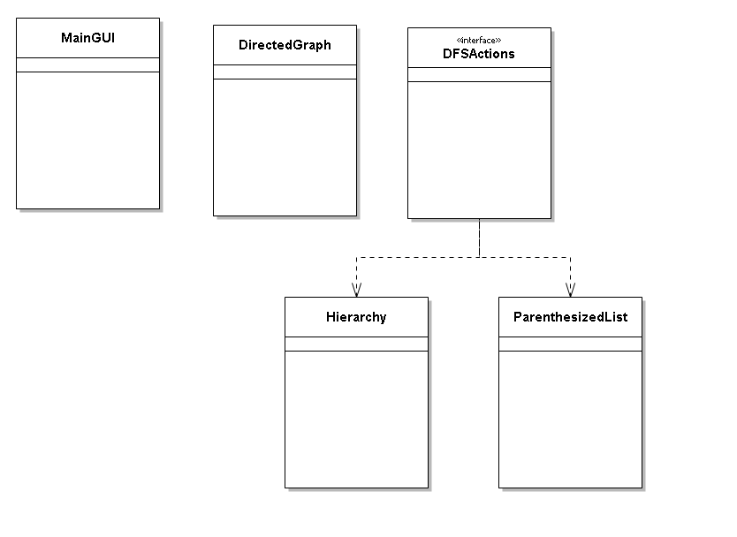

|  |  |  |  |  |
| --- | --- | --- | --- | --- |
| Test Case | Input | Expected Output | Actual Output | Pass? |
| 1 | Load File (“samplefile.txt)  Hierarchy  ParanthesizedList | ( ClassA ( ClassC* ClassE ( ClassB ( ClassD ClassG ) ClassF ClassH ) ClassJ ( ClassB ( ClassD ClassG ) ) ) ) | ( ClassA ( ClassC* ClassE ( ClassB ( ClassD ClassG ) ClassF ClassH ) ClassJ ( ClassB ( ClassD ClassG ) ) ) ) | YES |
| 2 | Load File (“samplefile2.txt)  Hierarchy  ParanthesizedList | ( ClassA ( ClassC ( ClassI ( ClassB ( ClassD ClassG* ) ) ) ClassE ( ClassB ( ClassD ClassG ) ClassF ClassH ) ClassJ ( ClassB ( ClassD ClassG ) ) ) ) | ( ClassA ( ClassC ( ClassI ( ClassB ( ClassD ClassG* ) ) ) ClassE ( ClassB ( ClassD ClassG ) ClassF ClassH ) ClassJ ( ClassB ( ClassD ClassG ) ) ) ) | Yes |
| 3 | Load File (“samplefile3.txt)  Hierarchy  ParanthesizedList | ( ClassA ( ClassC ( ClassI ( ClassB ( ClassD ClassG ) ClassF* ) ) ClassE ( ClassB ( ClassD ClassG ) ClassF ClassH ) ClassJ ( ClassB ( ClassD ClassG ) ) ) ) | ( ClassA ( ClassC ( ClassI ( ClassB ( ClassD ClassG ) ClassF* ) ) ClassE ( ClassB ( ClassD ClassG ) ClassF ClassH ) ClassJ ( ClassB ( ClassD ClassG ) ) ) ) | Yes |

Snapshots of Test Run:

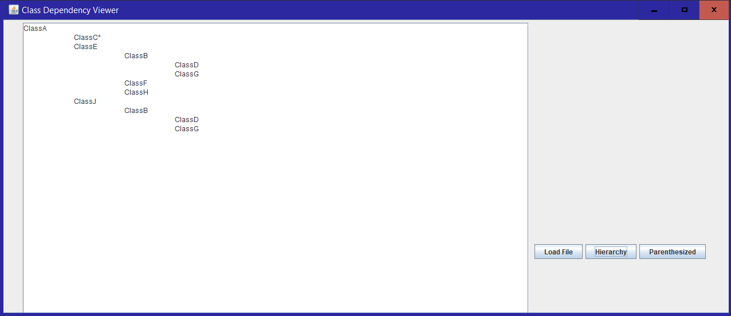

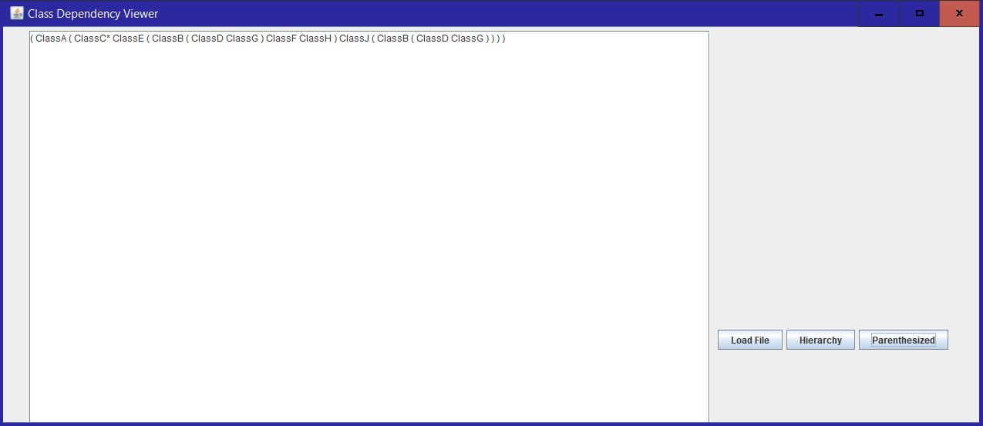

Reflection:

For this project, I used Swing instead of JavaFX to work on this program application. This was, indeed, one of the most challenging projects I have worked on in this class. Working on the hierarchy was especially hard because it took an extensive amount of time to get the program to correctly process the vertex, detect a cycle, and descend and ascend as necessary. I have had prior experience working on adjacency lists and matrices while I was a student at Montgomery College. One of the most important lessons I learned is that when going through each line of classes, you must go through the classes of each subclass existing in that line. Eventually, all the classes in that particular file would be accessed if every subclass and its subclasses is gone through. However, an instance where a class would be inaccessible to get to if no other class contains that particular class. Although it is probably not the simplest to explain, the concept of going through each line of classes makes sense. Cycles are detected by asterisks.